CAR RESALE PREDICTION

Abstract:

Cars are being sold more than ever. Many researches have been done in recent years on predicting used car price with data mining. An accurate used car price evaluation works as a catalyst in the healthy development of used car market. Therefore, arises a need for a model that can assign a price for a vehicle by evaluating its features taking prices of other cars into consideration. This price prediction model bridges this gap, giving the buyers and sellers an approximate value of the car using the multiple linear regression to predict the price.

Key Words:

Used Cars, Price Prediction, Data Mining, Features, Multiple Linear Regression

INTRODUCTION:

With the increase of car ownership, used car market shows great potential. An accurate used car price evaluation is essential for the healthy development of used car market. The prices of new cars in the industry are fixed by the manufacturer with some additional costs incurred by the Government in the form of taxes. But due to the increased price of new cars and incapability of customers to buy new cars due to the lack of funds, used cars sales are on a global increase. Predicting the prices of used cars is therefore an interesting and much-needed problem that needs to be addressed.

EXISTING SYSTEM:

Work on estimating the price of used cars is very recent but also very sparse. The conventional method involves going to a cars dealer, showing them the documents of the car and then an inspection of the car is performed in order to understand the state of the build and the engine of the vehicle. Only after such a long procedure and after waiting for around more or less than a week’s time or so, one can expect to get and idea the price range in which the car could be sold. In the digital world, there have been many different implementations that have been used to effectively predict the price of a vehicle using different algorithms right from the machine learning algorithms of multiple linear regression, neighbor, naïve bayes to random forest and decision tree to the SAS enterprise miner.

PROPOSED SYSTEM:

The proposed system provides users with the freedom to search all the available cars at one place without moving, anywhere and at any time. This methodology can aid in the decision making of the users who are looking to buy a used car. The basic objective of this system is to let user have a fair idea of what the vehicle could cost them. The system could also provide the user with a list of choices of different types of cars based on the details of the car the user is looking for. It helps give the buyer/seller with the substantial information based on which they can take the decision.

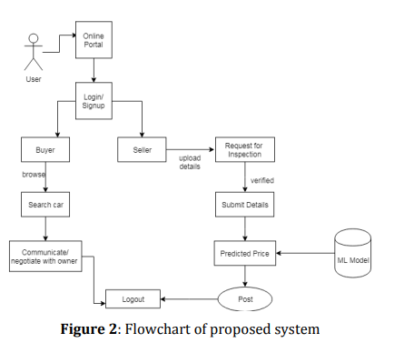

Proposed System Algorithm:

1. BROWSE THE WEB APPLICATION

2. NEW USER REGISTRATION.

3. USER LOGIN A. IF USER = BUYER 1. Visit the ‘Search Cars’ page. 2. Enter Details of the car you are looking for. 3. Select the car you want to buy

. 4. Verify the selling price of a car set by a seller with the ‘Machine Learning Model’ using a ‘Price Prediction’ feature.

5. Contact the car seller for further processing.

B. IF USER = SELLER

1. Visit the ‘Sell Cars’ page.

2. Enter the details of your car you want to sell.

3. Make request for verification of details. I. IF REQUEST = ACCEPTED

a. Machine Learning model will predict the right price for your car based on the details submitted.

b. Set a perfect selling price for your car and make it visible to everyone.

c. Manage your advertisements from your ‘Dashboard’. II. IF REQUEST = REJECTED

APPLICATIONS:

The basic objective of this system is to let user have a fair idea of what the vehicle could cost them. The website could also provide the user with a list of choices of different types of cars based on the details of the car the user is looking for. It helps give the buyer/seller with the substantial information based on which they can take the decision. In addition, following are a few other applications: 1. On-road price: User can get an approximate on-road price of any model for any city, on one’s fingertips. 2. Compare cars- Decide on the go: User will not have to wait for long time! They will be able to easily choose their favorite cars against different models with our prediction tool on our website.

FUTURE SCOPE:

Given the current working and design of the proposed systems, there is definitely a place for future enhancements. As better and more reliable technology comes ahead of us, more features can be added by providing a better experience by adding provisions for electric cars when the technology will be used by the public in large numbers.

CONCLUSION:

With the increase of car ownership, used car market shows great potential. An accurate used car price evaluation is essential for the healthy development of used car market. The automobile resale system would prove useful in helping the potential car buyers to find the best car for their budget and at the same time give a predicted price for the car one intends to sell, thereby proving to be a very useful tool helping people facilitate finding the best deal for their budget which is a very popular and trending niche in the used cars market.

The overall system being real-time and interactive with the user helps it to be an overall innovative proposed idea which can be easily implemented providing an overall satisfaction to the customer proving to become a successful business idea.

REFERENCES [1] Comparative Analysis of Used Car Price Evaluation Models, Tongji University, Shanghai 200000, China. [2] Prediction of Prices for Used Car by Using Regression Models, 2018 5th International Conference on Business and Industrial Research , (ICBIR), Bangkok, Thailand [3] Prediction of Used Cars’ Prices by Using SAS EM, Oklahoma State University [4] Predicting the Price of Used Cars using Machine Learning Techniques, International Journal of Information & Computation Technology. [5] A methodology for predicting used cars price